How to import taxonomy information
Applies to EwE version 6.5 and newer
EwE6.5 and newer offers means to search and import taxonomic information from external repositories. Currently, users can perform taxonomic searches via the World Register of Marine Species (WoRMS) and via a local version of a FishBase Access database.
- In EwE, load a model and launch “Define taxa”
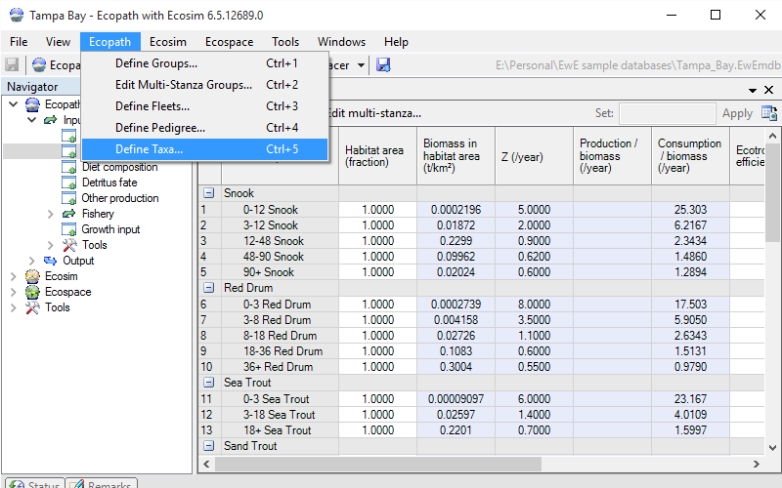
- The “Define taxa” interface displays access to all taxonomy search engines that EwE knows. Since these engines are defined via plug-ins, the number of items listed here may vary per installation of EwE
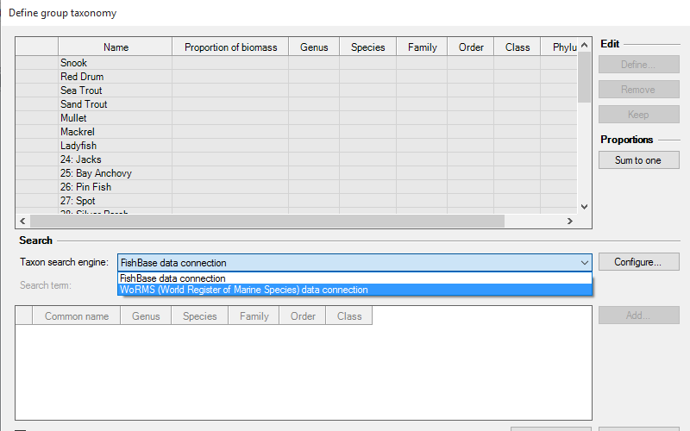
- The [Configure] button to the right of the taxon search engines provides additional options to fine-tune the taxonomic search engine.
Note that some search engines need to be configured before they can be used! If the ‘Search item’ entry box in this form is disabled this means that configuration is necessary.
Now, select the Taxon search engine that you wish to use, and select additional search options provided by the taxonomy search engine. Once you have typed (or Copy/Pasted) more than 4 characters in the Search Item box the taxonomy search engine returns the results that match that term.
Please note that some search engines may take quite some time to return results. Please be patient
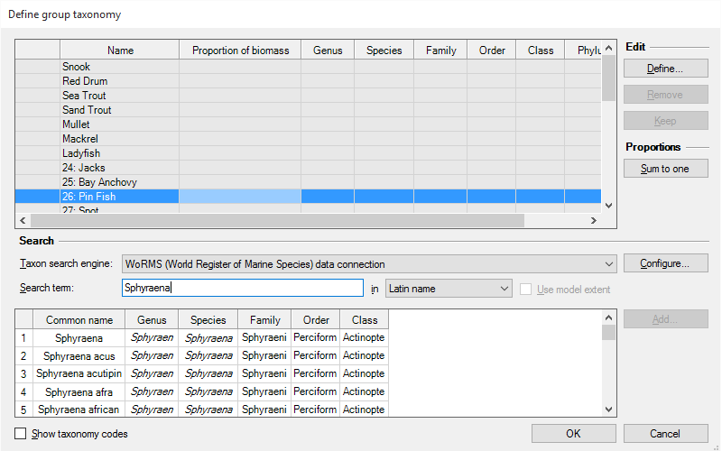
- To assign a species that you found via a taxonomic search engine to a functional group in EwE, select both the target group and the species, and click the [Add] button. The species will be added permanently when you click [OK]
- You can also add species by hand by selecting a target group and pressing the [Insert] button
- To remove a species from a group, select the species within the group and click [Remove]. Note that the species is not immediately removed, but is flagged for deletion when you press [OK]
- Multi-stanza groups can only have one species assigned
- Per functional group you can set the relative amount that each species contributes to the group biomass. Pressing the [Sum to one] button will normalize these proportions

